FOR IMMEDIATE RELEASE: October 26, 2020
For More Information Please Contact: Ben Berlinger at Ben.Berlinger@usda.gov

Students Compete in Range Judging Contests
By: Ben Berlinger, CO Section of the Society for Range Management

High school agriculture students from across eastern Colorado competed this fall in three Range Judging and Plant Identification contests. The events were held October 7th and 8th in New Raymer and La Junta respectively. On October 15th the range judging event was held in Burlington. These educational events were sponsored by the Colorado Section of the Society for Range Management (SRM) as part of their youth activities program. Other sponsors were the Prairie School District, West Greeley Conservation District, Rocky Ford School District, West Otero Timpas Conservation District, Burlington/Stratton School Districts, and the Burlington Conservation District.
The Range Judging Contest is one of many Career Development Events (CDE’s) agriculture students can participate in to test their skills and knowledge learned through their agricultural education classes. Through the Range Judging Contest students are tested on their plant identification skills and reading the landscape to determine the ecological site, condition of the rangeland, amount of usable forage, and number of animals that can be supported on the land.
There was a total of 180 agriculture students representing 18 FFA chapters who participated in these events. Students were divided into three groups to identify 30 range plant species and two ecological sites. During the plant identification portion students had 60 seconds to identify the plant before moving on to the next plant. At the two ecological sites, students had 40 minutes to complete a rangeland inventory to determine the ecological site, condition of the site, and a range management scenario that was provided and required the students to recommend the best range/grazing management practices. Judging the two ecological sites also tested the students plant identification skills.
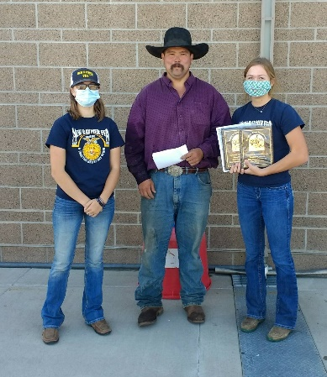
Colorado Section SRM president Josh Tashiro, along with New Raymer FFA president Montana Goodman (left), presented awards to high scoring individual Bobbie Schreiner (right) at the New Raymer event. The high scoring team awards were provided by the CO Section SRM: New Raymer – 1st Place Prairie FFA, 2nd Place Woodlin FFA; La Junta/Rocky Ford – 1st Place Branson FFA, 2nd Place Fowler FFA, 3rd Place Kim FFA; Burlington – 1st Place Lone Star FFA, 2nd Place Stratton FFA, 3rd Place Arriba-Flagler FFA.
(more)
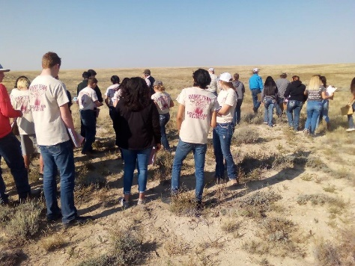
At the La Junta/Rocky Ford event students completing the rangeland inventory, site condition, and range management scenario on a Limestone Breaks ecological site.

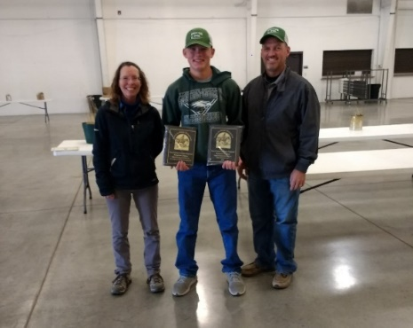
At the Burlington event Braden Wedel (center) of the Stratton FFA accepts his recognition for highest individual achievement from Julie Elliott (left) CO Section SRM, and Cory Wedel (right) Stratton FFA Advisor.

Thank you to all the FFA Advisors, bus drivers, local Conservation Districts, the Colorado State Land Board and the USDA-Natural Resources Conservation Service for helping make these events a success for all the participating high school ag students. A special thank you goes out to Joe Kugler, Randy Kurtz, and the Queen and Buol ranches for allowing the use of their rangeland for this educational youth event.
###

