Colorado Section of the Society for Range Management
Excellence in Rangeland Conservation Award Nomination
3R Ranch – Betsy and Reeves Brown
The 3R ranch is owned and operated by Reeves and Betsy Brown. They purchased the ranch in 1981 having moved from the Austin Texas area. The ranch sits in the foothills of the Wet Mountains located in western Pueblo County about 5 miles southeast of the town of Beulah. The physical address of the ranch is 7100 3R Road S, Beulah, CO 81023.
The ranch was originally part of a Spanish land grant from the King of Spain to Gervacio Nolan. The ranch is rich in Native American history especially the Ute Indians. Tepee rings, Indian rock art, and artifacts can be found on the ranch. The south fork of the St. Charles River flows through the ranch. Through the years the 3R Ranch land holdings grew to its current 11,000 deeded acres. The land uses consist of rangeland and irrigated hayland. The dominant ecological sites are Loamy Foothill, Clayey Foothill, Shallow Foothill, and Pine Grassland. Major grasses include western wheatgrass, blue grama, needleandthread, big bluestem, and sideoats grama. Important woody plants include skunkbush sumac, currant, Gambel oak, walking stick cholla cactus, and ponderosa pine.
The ranch is operated as a cow-calf production system. SimAngus cows are run year-round on the ranch with the calves weaned and sold in the fall. The Simental x Angus breed results in hybrid vigor of the offspring and is ideal for meeting the production goals for the ranch. Bulls are purchased from higher elevation seed stock to avoid brisket disease (PAP) in the cow herd. Calving on the 3R Ranch occurs from April 20 to June 5. When the Brown’s moved their cows from Texas they were January calves with short hair. Betsy says she likes her calving time; “green grass with not much snow”!
The Browns have worked hard to improve the irrigation, use the best-known conservation methods, and improve the range forage. For the last 30 years Holistic Resource Management has been practiced improving quantity, variety and quality of the grasses through multi-paddock time controlled grazing management. This grazing method creates more vegetation on the ground which in turn prevents excessive runoff of rain or snow. This allows the water in creeks to be clear.
The current grazing management being implement on the ranch is based on a holistic approach that considers the entire rangeland ecosystem in the decision making process. The Holistic Resource Management© model provides the guidelines for the range management philosophy of the Browns. Presently their grazing program consist of 65 paddocks, the bulk of which average about 100 acres. There are a few larger pastures that have not been cross-fenced due to the steep terrain and shallow soils. Three herds are run through the multi-paddock grazing system for most of the growing season. After breeding the heifers are combined with the cows to allow more paddocks per herd in the grazing rotation. Cows are wintered on the irrigated hay fields located close to the headquarters.
Livestock water development required to facilitate the grazing management program has been minimal due to the senior water rights on the ranch. However, the Browns have installed five miles of livestock water pipeline together with eleven stock tanks that provide reliable water. Multiple paddocks are watered with each tank.
Due to the holistic grazing management implemented by the Browns the health of the range has improved. They note that when they purchased the ranch undesirable plants such as cheatgrass and sleepygrass were abundant. Today these plants have been significantly reduced on the ranch, while desirable grasses have increased. The ecological functions of nutrient cycles, water cycling, energy flow, and biotic community integrity have all improved as shown by improved healthiness of the rangeland and wildlife on the ranch.
As an additional enterprise the Browns manage a big game hunting operation on the ranch. A hunting lodge/cabin was built to accommodate the fee-hunting program implemented by the Browns. The lodge offers a very diverse landscape of mountains, canyons, prairies and year-round streams that provide irrigation for lush hay meadows. The ranch shares this terrain with a variety of wildlife, including mule deer, mountain lion, turkey, bear and elk in abundant numbers.
Hay is produced by use of irrigation water application. Three center-pivot sprinkler systems provide efficient application of water. The source of irrigation water is diversion of senior water rights out of the St. Charles river. Hay crop consists of a mixture of high quality grasses with a minor amount of legume (alfalfa). The harvested hay is fed on the ranch.
The Browns are placing permanent conservation easements on the ranch to forever keep it whole and in open space. Colorado Open Lands easements have been attached to the ranch. Four easements have already been completed and the last easement to cover the irrigation water will be executed this year. The entire ranch, and the associated water rights, will be under a permanent conservation easement. Protecting open space, water, and wildlife habitat on the 3R Ranch is an essential part of the rangeland conservation and stewardship established by Betsy and Reeves.
Besides their involvement in many community organizations and ranch educational events in the Beulah area, Betsy and Reeves have been members of and involved with the Center for Holistic Resource Management (HRM). In fact, Betsy is the past president of the HRM Board of Directors. She served in that capacity for a three-year term, requiring several trips to the HRM headquarters in Albuquerque, NM and, to her dismay, many days away from the ranch! Betsy also attended two schools put on by Bud Williams on low-stress livestock handling. She states, “Before Bud Williams I considered gathering cattle a bad nightmare and, after attending, any cattle moving was a joy for the cattle and the people”.
This nomination is being submitted due to the exemplary rangeland stewardship displayed by the Browns over the past three decades. The land management ethic employed by the Browns is truly inspiring to all who care about the conservation of our rangelands. It is indeed my honor to nominate the 3R Ranch, Betsy and Reeves Brown, for the Excellence in Rangeland Conservation Award from the Colorado Section of the Society for Range Management.

Nomination submitted by:
Ben Berlinger,
2318 Raton Avenue,
La Junta, CO 81050
CO Section SRM member in good standing #1204
Certified Professional in Range Management #CP01-264

Images pertaining to this nomination are on the following pages.
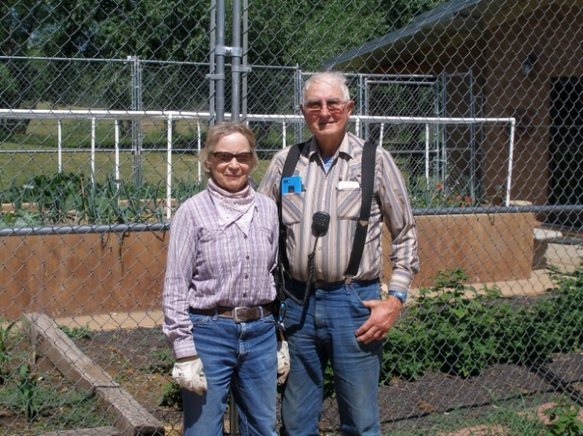
Betsy and Reeves Brown, owners & operators of the 3R Ranch.
In the background is their garden located at the ranch headquarters.

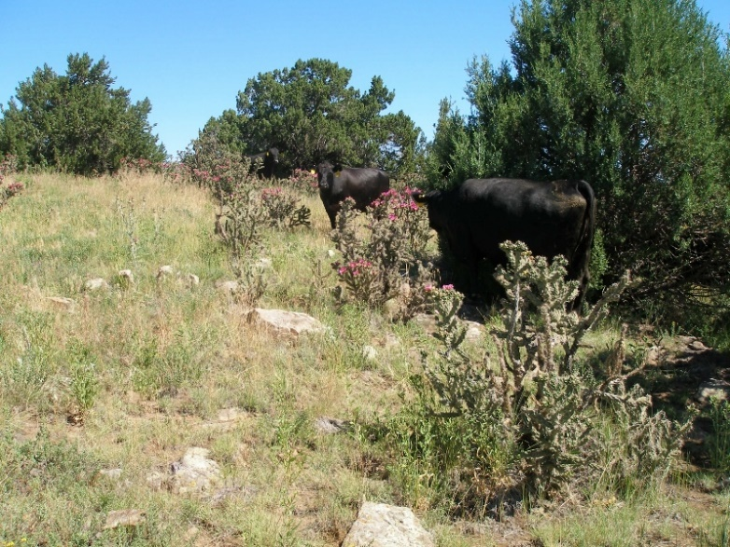
3R Ranch cows grazing an upland ecological site with
cholla cactus in full bloom.

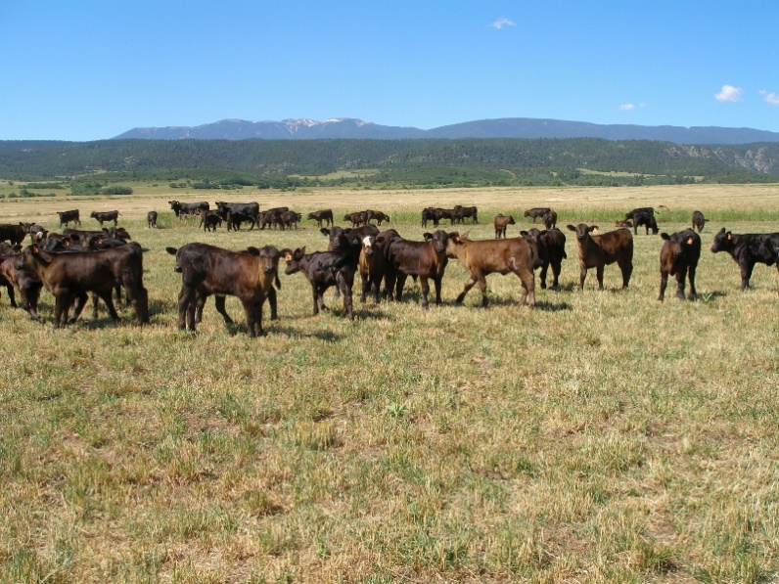
SimAngus calves grazing hay aftermath. In the background
is the Wet Mountain range with snow cover on the top of
Greenhorn Mountain (elevation 12,356 feet).

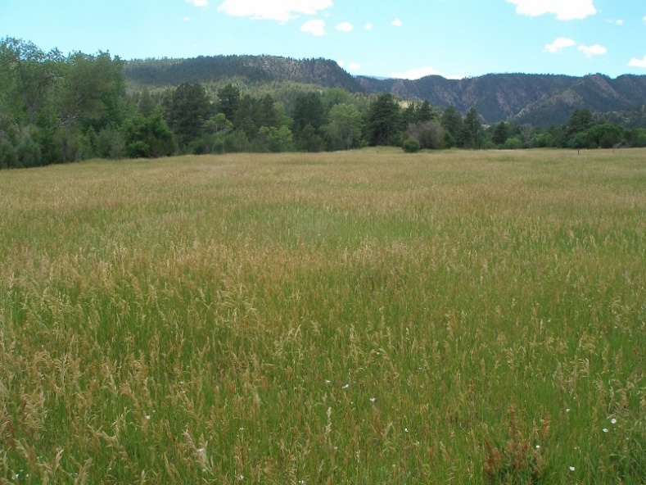
Smooth brome has become dominant on this grazed meadow
on the ranch. The south fork of the St. Charles river flows
in the background providing livestock and irrigation water
to the 3R Ranch.

