2018 FALL RANCH TOUR
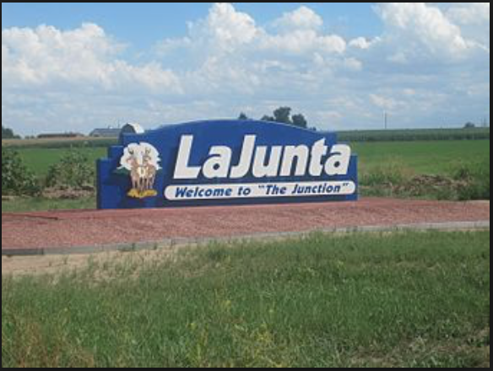

September 21, 2018 8:30 a.m. to 3:00 p.m. at the Leininger Ranch, La Junta, Colorado. Cost is $10, $5 for students and includes lunch.
Leininger Ranch has been raising Commercial Angus Cattle for over 20 years in Southeast Colorado. The herd started with Angus-Simmental-Gelbvieh cross cattle, but has been bred back to Purebred Angus bulls. Replacement heifers have been kept since 2006, and the current herd has been well adapted to dry conditions. Many miles of pipeline and cross fencing have been added since the Leiningers bought the ranch in 1995. Zane and Barb have worked hard to ensure proper grazing management and proper herd health are the top priorities. Current projects on the ranch include cedar/juniper removal and ever-adapting drought planning. The Colorado Section - Society for Range Management and Leininger Ranch are pleased to provide this learning opportunity. ​
For details, directions and more information, please click the button at the bottom of the column to download the flyer.

